Honda GX series engines

http://engines.honda.com/models/application/generator

Question: If we attach the GX engine to a 1.5 kW electric generator, and run at 1,800 RPM, which is the best engine for our application. See the power curves below that I copied from the Honda web site.

Potentially, we could machine the cylinder head to increase the compression ratio to 12:1 to take advantage of the higher octane rating of natural gas.

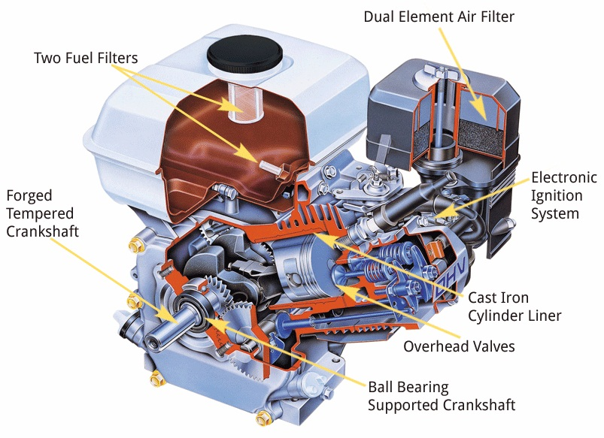

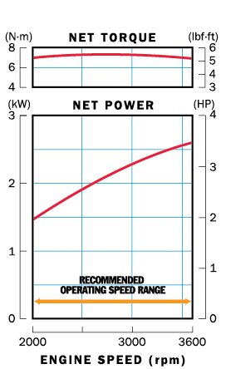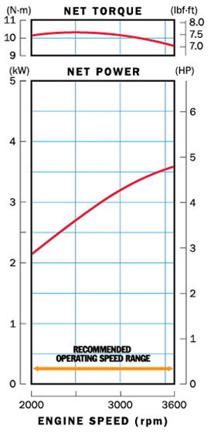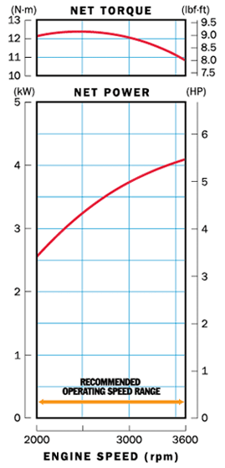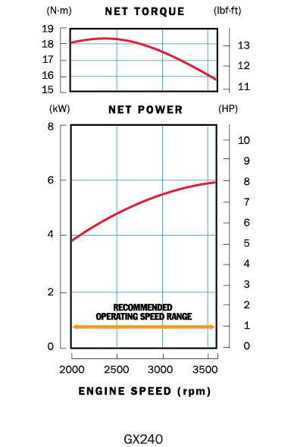

GX 120 (118 cc) GX 160 (163 cc) GX 200 (196 cc) GX 240 (270 cc)

Shaft Options

H type Reduction type PTO
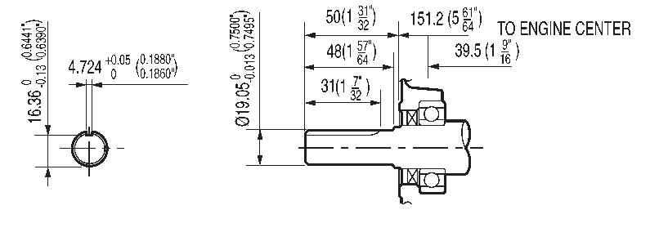

L type Reduction type PTO
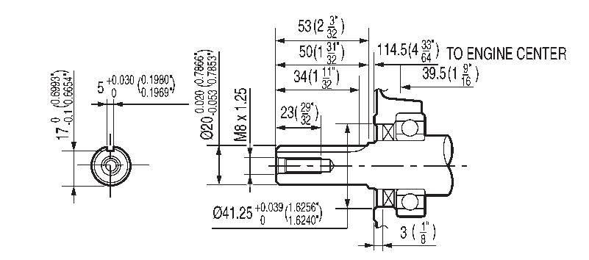

Q type Straight shaft
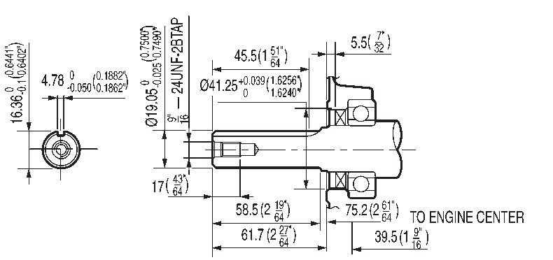

R type Reduction type PTO
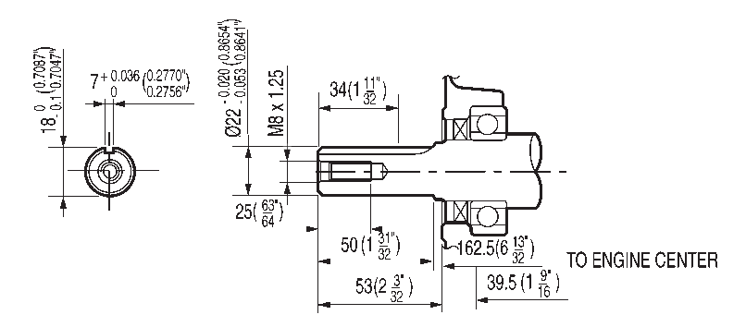

S type Straight shaft (metric)
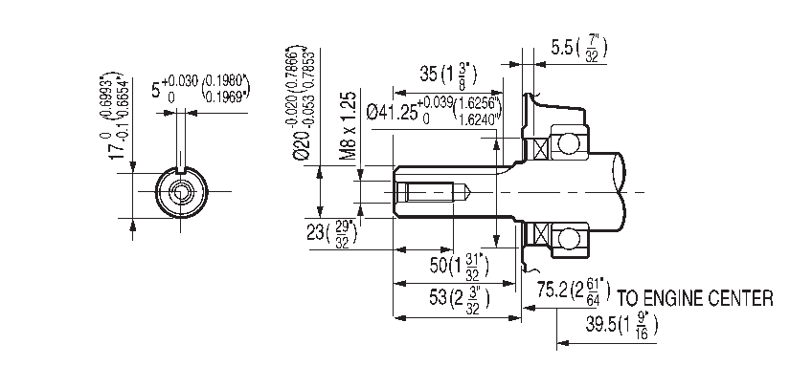

T type Straight shaft
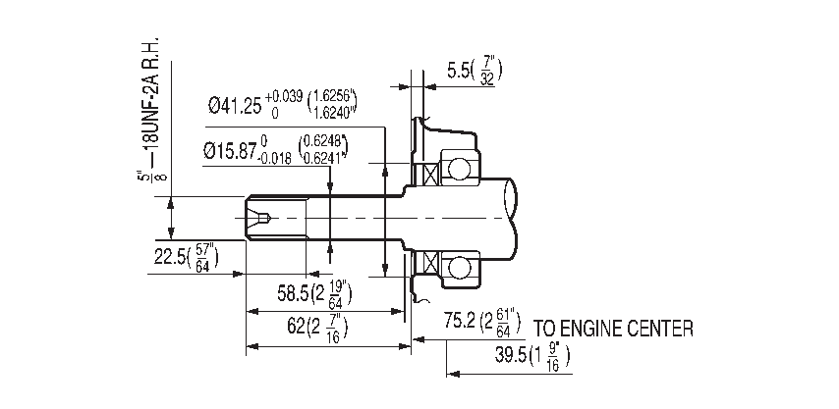

V type Tapered shaft
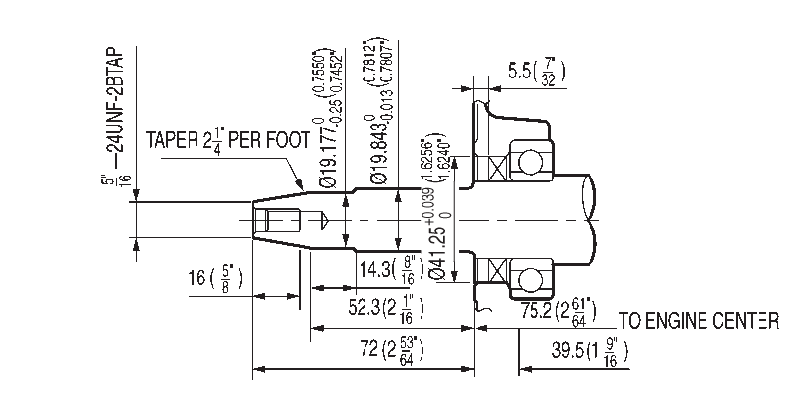

Honda GX racing modifications / racing cart info:

http://gokartmods.com/gx200-modifications/ Shows milling instructions to increase C.R.

